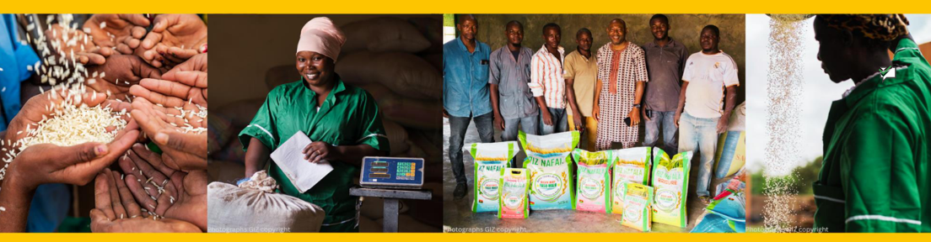

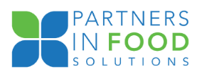

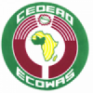
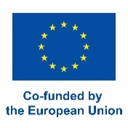
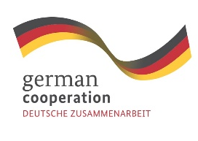

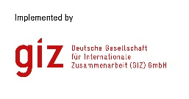
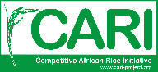

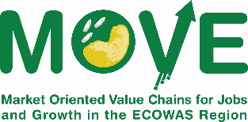

Gesellschaft für Internationale Zusammenarbeit (GIZ) Market-oriented Value Chains for Jobs and Growth in the ECOWAS Region (MOVE) project, Bühler Group and Partners in Food Solutions.

CALL FOR APPLICATIONS

Applications are open to interested Rice Processors with experience in the field of

the 5-course Rice Miller Business Training (RMBT) Program and Business Development Support (BDS)

Location: the program will be divided in Kano & Lagos

Introduction

GIZ-MOVE, Bühler Group, and Partners in Food Solution are offering a unique and in-depth training & coaching program for rice processors in Kano and Lagos state, Nigeria. Over a span of 10-months, rice processors will be trained on key elements of mill management, coached and supported to put theory into practice. If you are interested to know more about it, continue reading below.

GIZ-MOVE

The Market-Oriented Value Chains for Jobs and Growth in the ECOWAS Region HYPERLINK "https://www.move-giz.org/"(MOVE) project focuses on building resilient cashew and rice value chains to contribute to the creation of jobs and income in West Africa, with ECOWAS as its main political partner. MOVE represents the merger of two previously well-established regional projects: The Competitive Cashew Initiative HYPERLINK "https://www.comcashew.org/"(ComCashew) and the Competitive African Rice Initiative HYPERLINK "https://www.cari-project.org/what-we-do"(CARI). Both respective brands (ComCashew and CARI) are kept under the umbrella of the MOVE project. Its goal is to ensure long-term, sustainable results and competitiveness in six (6) West African countries, Ghana, Nigeria, Ivory Coast, Burkina Faso, Sierra Leone, and Senegal. As an entry point to the respective value chains, MOVE uses multi-stakeholder partnerships at the heart of its implementation and leverages its previous work in the region. The main partners are therefore rice processors, input suppliers, or mechanization service providers who are working in the up and down stream value chain.

Partners in Food Solutions

Partners in Food Solutions (PFS) is an independent nonprofit organization working to strengthen food security, improve nutrition and increase economic development across Africa by expanding and increasing the competitiveness of the food processing sector. We link corporate volunteers from our consortium of world-class food companies (Buhler, Cargill, Dsm-Firmenich, General Mills, Hershey. Ardent Mills, and JM Smucker) with promising entrepreneurs in more than twelve African countries. Our partner companies are committed to improving food security by empowering their employee volunteers to share expertise and a combined 700 years of food industry experience with dynamic and promising food companies throughout Africa.

Bühler Group

Bühler is a Swiss family business with more than 170 years of experience, specializing in the manufacture of agro-industrial equipment, particularly for the transformation of cereals into flour and other agricultural raw materials into ready-to-eat finished products. To date, Bühler employs more than 13,000 people and generates a turnover of 3 billion dollars, 5% of which is reinvested in research and development. Bühler's ambition is to create innovations to make the world a better place, with a particular focus on promoting healthy, safe, and sustainable industrial solutions.

Program description.

The call for applications is specifically looking for mills intending to improve their mill operations. GIZ-CARI/MOVE, Bühler, and PFS are offering an in-depth specialisation in different topics through coaching and training. The program offered consist of two different parts: The first part is the Rice Miller Business Training (RMBT) which is a modular training program (each training module consisting of 3 days) that will allow mill owners, mill managers and mill staff to improve their everyday management of the rice mill and deepen their knowledge on mill management. The second part is Business Development Support (BDS) which focuses on coaching and individual support to mills. The RMBT program consists of the following five modules:

- Rice Mill Operations

- Practical Marketing for Rice Mills

- The Business of Rice Milling

- Finance Essentials for Rice Mills

- Developing Profitable Farmer Services

The training program will take around 10 months with one course taking place every 2 months, the mills are expected to participate in all 5 modules with the most fitting staff of their mill. Each course is a physical three-day training. The mill is expected to participate in every course with at least one staff member who is currently conducting the work within the company and the mill manager/owner. It is important that these two persons attend the training, as one is the executive power and one the implementing power.

The RMBT Program will be conducted in two rounds, one in 2024 and the other one starting in 2025. In 2024, the program will start in between September – November. Each round will accommodate around 10 mills, meaning in total 20mills will be selected in total over the two years. One round of the RMBT will be conducted in Kano and the other one Lagos.

Business Development Support (BDS)

The RMBT program will also have a special BDS support for a small selection of mills attending the program. For these mills, in addition to the RMBT courses, they will receive coaching sessions in between each of the courses to apply the knowledge acquired to their mill. If you are interested in participating in BDS, kindly insert it in your application form.

Requirements for mills

We are looking for partners who are willing to change! Mills who are willing to invest time to participate in the training, coaching sessions and willing to partner with GIZ-MOVE, Bühler, and PFS:
- The course is aimed at medium to large sized mills, preparing to scale up operations, upgrade equipment and improve efficiency and rice quality.
- Mills that are motivated & willing to change.
- Mills need to be in business for at least three years in business.
- Have a team of at least 10 employees.
- Mills are required to invest time to participate in the courses, for coaching and for M&E. The intervention will take around 10-months’ time. However, the duration of one coaching session will not exceed maximum of a half day.
- Each course will be attended by the owner, CEO or manager and the staff member of the mill that is responsible for that area of work related to each training thematic.
- At least enrol 30% of its participants that are female. This is negotiable if you provide an explanation that you do not have other right staff to participate in the training.
- Be willing to hand in M&E related data to GIZ and conduct a baseline and endline study.
- Be willing to communicate with GIZ on success stories, feedback or other sorts of communication work.
- Located geographically in and around Lagos and Kano or the south of Nigeria. If your mill is located outside of this area and you still want to participate in the training, there will be very few scholarships provided for a small selection of processors for transportation and accommodation.
- All applicants/participants need to be able to speak fluent English.

Costs:
- Following cost for the training will be covered: Trainer, training material, venue, and food during the training.
- No transport or accommodation allowance
- No per diems will be paid.
- There will be very few scholarships provided for a small selection of processors coming from outside the intervention area covering transport & accommodation. Kindly indicate in the application sheet if you are willing to participate when covering your own cost.

How to apply:

The applicants are expected to fill out the excel sheet and hand in the CVs of all applicants of your mill afterwards to move@giz.de via E-mail. Mills who apply should only register mill personnel who are already working within the thematic area. We highly encourage female led mills to apply and we also encourage persons with disabilities to apply.

The deadline to submit the application is 2nd of September 2024.

For further information, email us on the following email address: move@giz.de.

